|  |  |  |  |
| --- | --- | --- | --- |
| **Vdc**  (volt) | **Vd**  (volt) | **VR**  (volt) | **Id = VR / R**  (mA) |
| 0.1 | 0.1V | (0.1-0.1)V = 0V | 0 mA |
| 0.3 | 0.3V | (0.3-0.3)V = 0V | 0 mA |
| 0.5 | 0.498V | (0.5-0.498)V = 0.002V | 0.002 mA |
| 0.9 | 0.622V | (0.9-0.622)V = 0.278V | 0.278 mA |
| 1 | 0.629V | (1 -0.629)V = 0.371V | 0.371 mA |
| 3 | 0.677V | (3-0.677)V = 2.323V | 2.323 mA |
| 6 | 0.698V | (6-0.698)V = 5.302V | 5.302 mA |
| 9 | 0.710V | (9-0.710)V = 8.290V | 8.290 mA |
| 10 | 0.713V | (10-0.713)V = 9.287V | 9.287 mA |
| 14 | 0.722V | (14-0.722)V = 13.278V | 13.278 mA |
| 17 | 0.727V | (17-0.727)V = 16.273V | 16.273 mA |
| 20 | 0.732V | (20-0.732)V = 19.268V | 19.268 mA |

Submitted on time? (YES/ NO): Yes

**Task 01**: Complete the Table 01. **40 points**

**Task 01:** Attach screenshots of the simulated circuit of the experiment showing all Multimeter/ simulation readings as mentioned in the class. **30 points**

**Task -03:** Discuss your observation from this experiment in brief. **30 points**

**NOTE**: You must submit PDF of this file

NAME: Md. Rifat Ahmed - ID: 1931725042

**Task: 01**

Table - 01

**Task: 02**

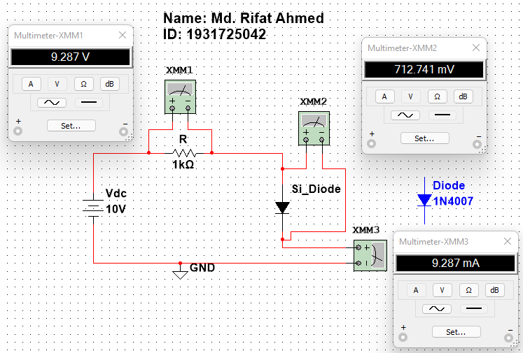

Simulation

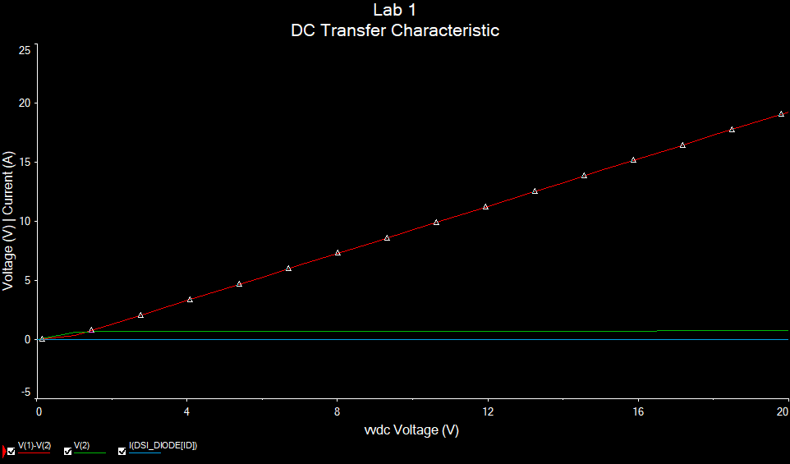

Graph

**Task: 03**

**Discussion:**

In this experiment, we learnt how to use Multisim live and Multisim and then we learnt about the threshold voltage for a silicone diode. So, when simulating the circuit, we took many values and checked the voltage across the resistor, voltage and current across the diode and noted them in Table – 1. Now from there we can see that the current across the diode is zero until 0.3V and then it was close to zero at 0.5V but then it started to rise. So, the threshold voltage is around 0.3V to 0.5V but after that the current across the diode keeps increasing a lot even for a small increment of the voltage source and we can see that in the Graph that the (red) line representing the current through the diode was increasing a lot.